The Digestive System

Describe the difference between physical and chemical digestion. Give an example of each one.

Physical digestion is __________________________________________________________ ___________________________________________________________________________

An example of physical digestion is ___________________________________

Chemical digestion is _________________________________________________________ ___________________________________________________________________________

An example of chemical digestion is ___________________________________

Label the diagram of the digestive system using the words below:

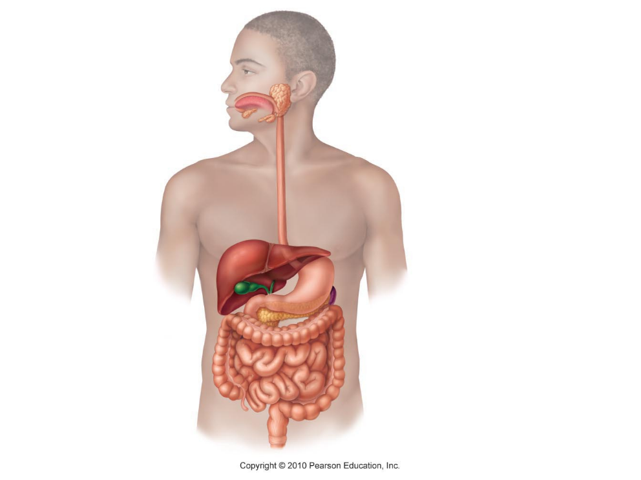Stomach, Large intestine, Mouth, Liver, Rectum, Gall bladder, Small intestine, Oesophagus, Anus, Pancreas

2. Teeth

1. Mouth

3. Tongue

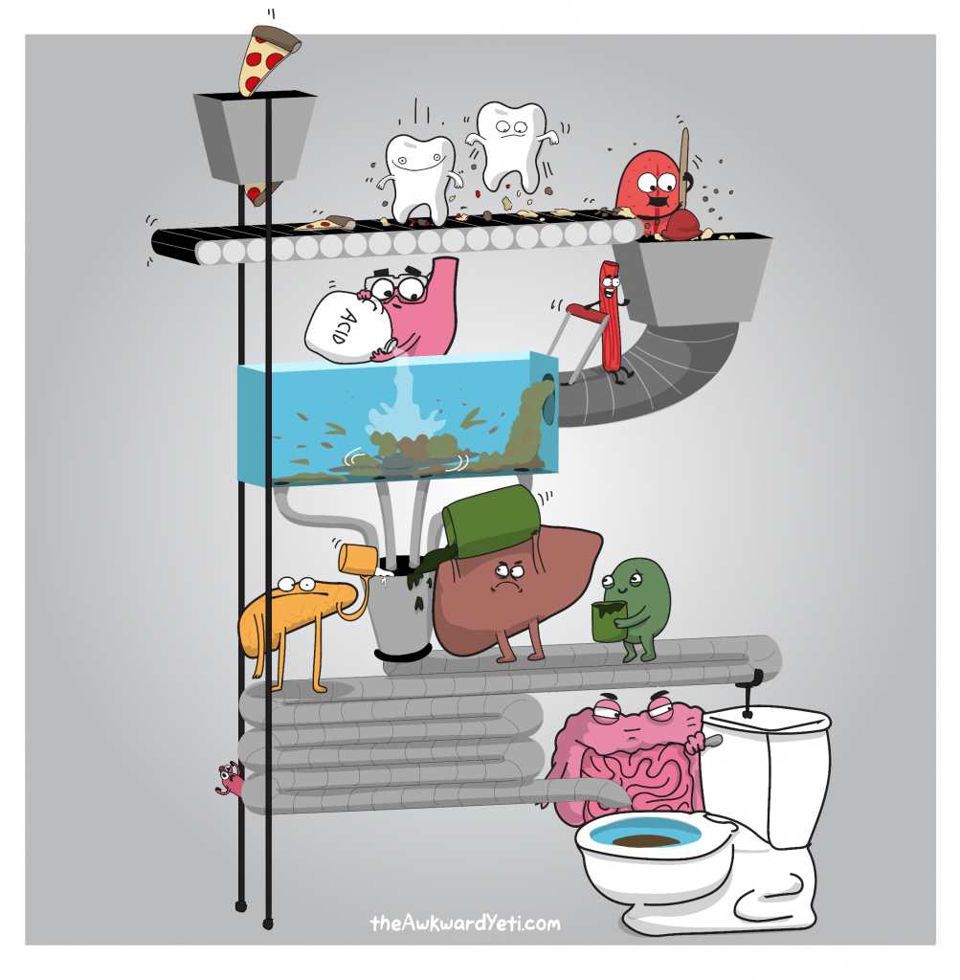

9. Small Intestine

11. Rectum and Anus

10. Large Intestine

6. Pancreas

8. Gall Bladder

7. Liver

4. Oesophagus

5. Stomach